Spring boot Introductions:

# **Introduction to Spring boot | Its Advantage over Spring MVC and Servlet:**

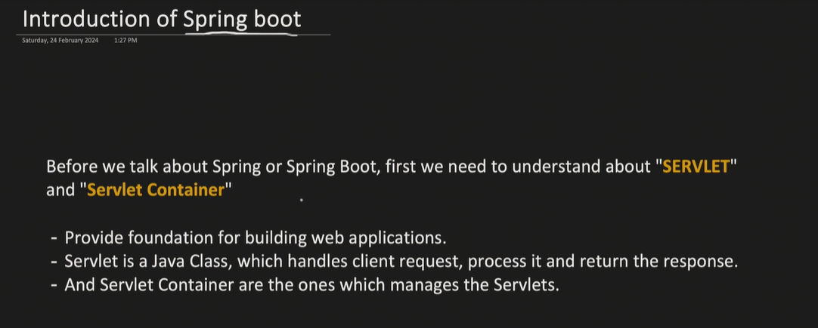

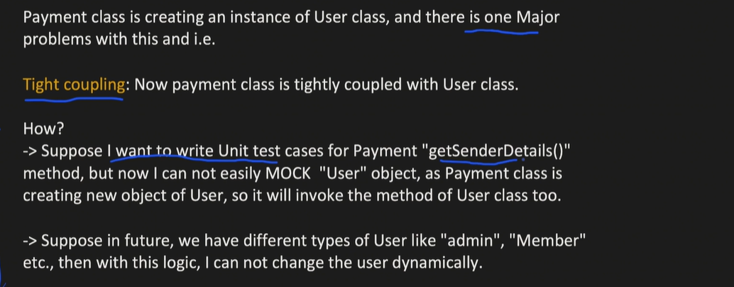

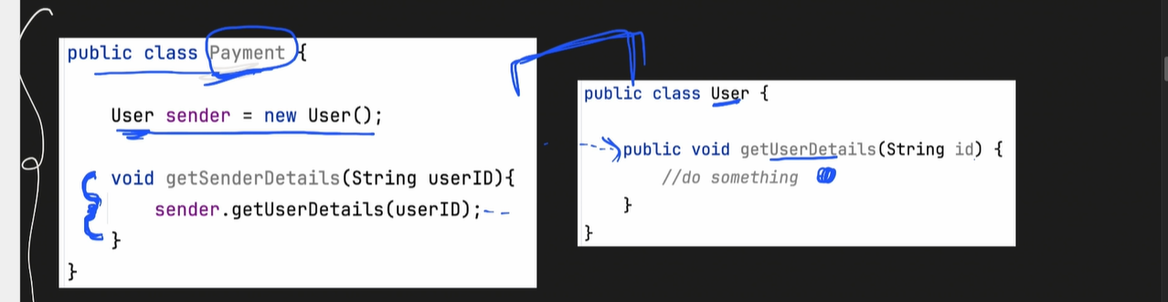

Dependenyc Injection is the solution for the above tight coupling problem

## **Spring MVC Model:**

How we move out from Servlet to Spring MVC

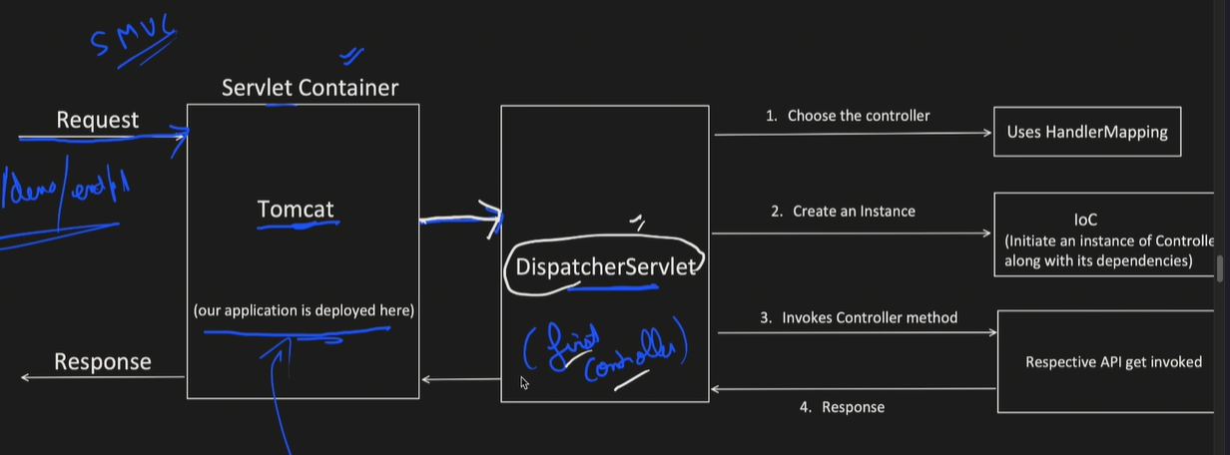

Dispatcher servlet is the first controller which will take the request and match the pattern in out controller class and redirect the request towards that class

**Spring MVC Project Outlook and drawback**

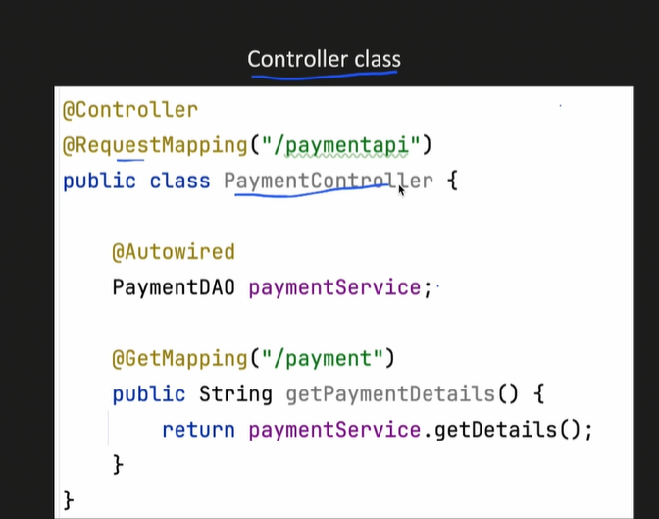

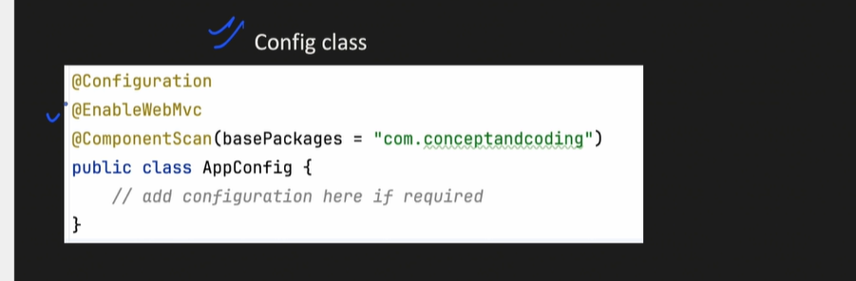

**@EnableMVC loads lot of dependency to run the projects**

**In spring Mvc we have to create Dispatcher servlet to route the request to appropriate controller class below is the code for the same.   
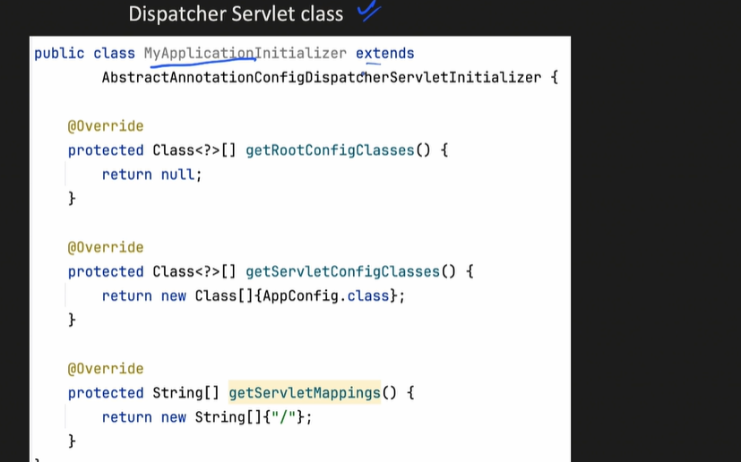**

## **Spring MVC To Spring Boot**:

Springboot solves the dependency management where we don’t need to provide the version in pom.xml

* We just have to give dependency internally it will load the compatible version of the same.
* 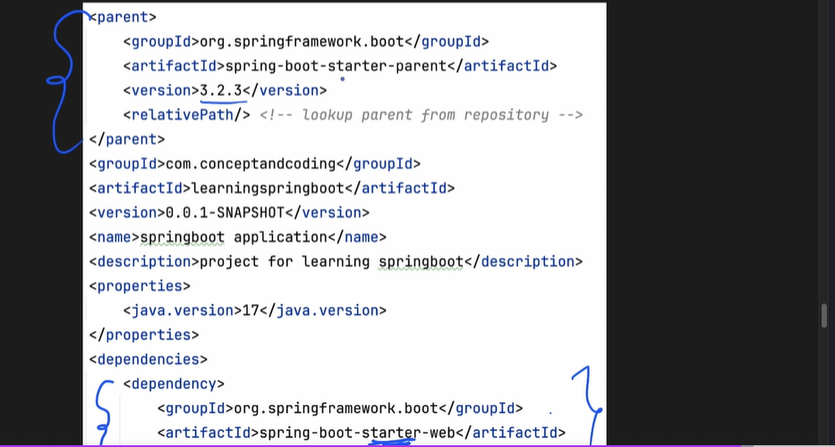
* Autoconfiguration we have in SPRING BOOT as we have seen above the in AppConfig class we have write so many annotation in Spring boot we just need **@SpringBootApplication**
* Embedded server we get in Spring boot We don’t need to configure the server any where

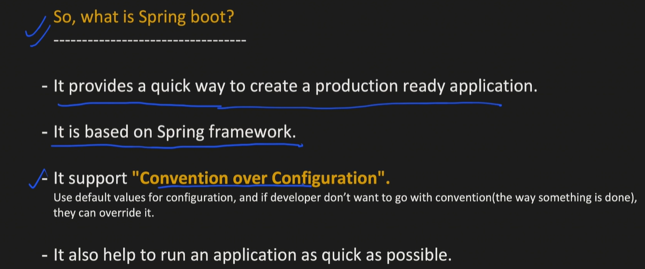

# **Spring boot Project setup and Layered Architecture Introduction**

Stand alone application we will create JAR

WAR when we create a bundle of application we have JS, HTML, CSS and all.

## Layered Architecture of Spring Boot;

